COSC 3P95 Assignment 2

Brett Terpstra 6920201
Michael Boulos 6973523
----------------------------------------------------
The work distribution of this assignment is to both parties satisfaction.

This assignment is unfair and poorly designed. It should not take people like us a week of all day working for subcompletion results.

Auto / manual: No. Auto restricted usage of our favourite language (C++ lacks auto support) and auto does not support java's builtin sockets (it was neglected to mention that a framework was required, now count 5 that we have to learn just to do this assignment btw)

Thus only manual is used.

Implement and analyze at least two different sampling strategies: AlwaysOn and
Probability sampling (below a 40% rate).
Java's lack of macros makes switching between the two strategies insanely difficult and time consuming. Doing so would require the creation of object wrapers and as such maintianing a small framework on top of the OTel framework just for this assignment is not in my interests. Enough time has been wasted on this disapointment.

Thus only always on was conducted.

Advanced features, we have:
Compression (LZ4)
Chunking & Streaming (Built the application around this from the begining. Hard to call it an "advanced feature")
Concurrency Models (Using a threadpool to limit number of threads)
Data Integrity (LZ4 comes with XXHash so we are using it)

Use Open-Telemetry to collect relevant data or metrics with and without the
advanced features.
Yeah this code wasn't designed for that and having this requirement is clearly only here to add more work for us. It really isn't needed.

Use an Open-Telemetry compatible external tool like Jaeger, Prometheus or
Grafana to visualize the spans and telemetry data.

Oh goodie more things to setup and learn about? How are people who've never done anything remotely like to supposed to just all of a sudden know how to do this kind of stuff? Like I'm a good sysadmin, I've been doing it for years and self host pretty much everything yet it still took me at least a day of working ALL DAY just to get the Jaeger instance setup and working with the Java side. (after abandoning Prometheus because that would require grafana to produce anything near useful and that my personal grafana instance is apparently offline).

The frontend can be found here:
for Server
https://jaeger.skynet.tpgc.me/trace/5e5cf5b9d2d4c6d31b9cad0022b73bc0
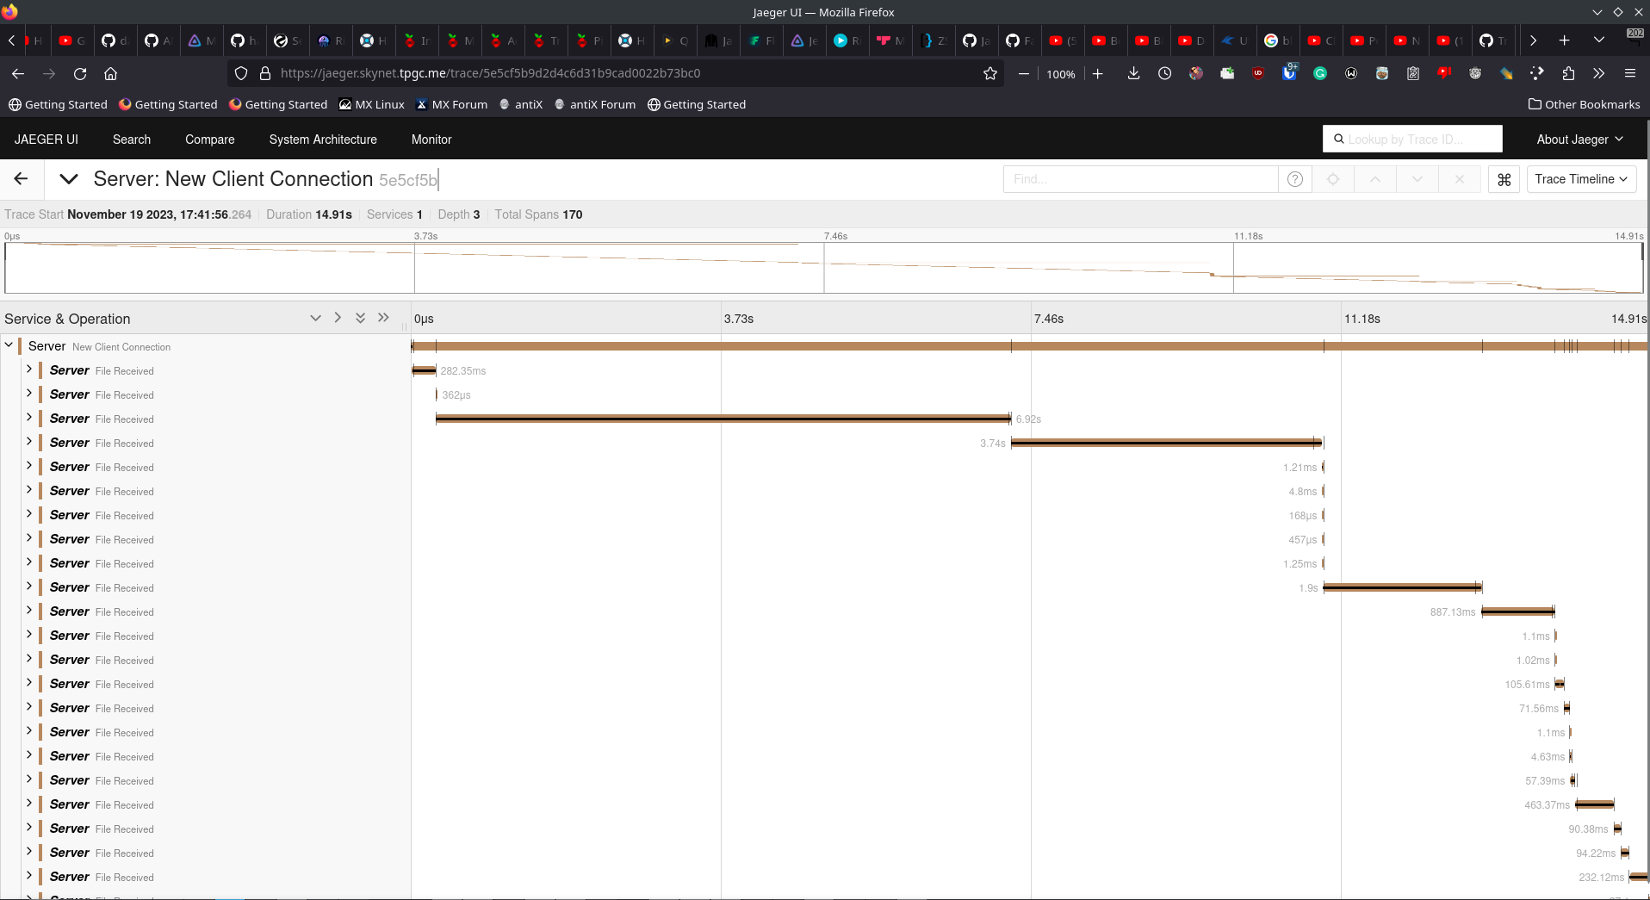

for Client
https://jaeger.skynet.tpgc.me/trace/4f85dd2b5562f090330e9b1bd8915842
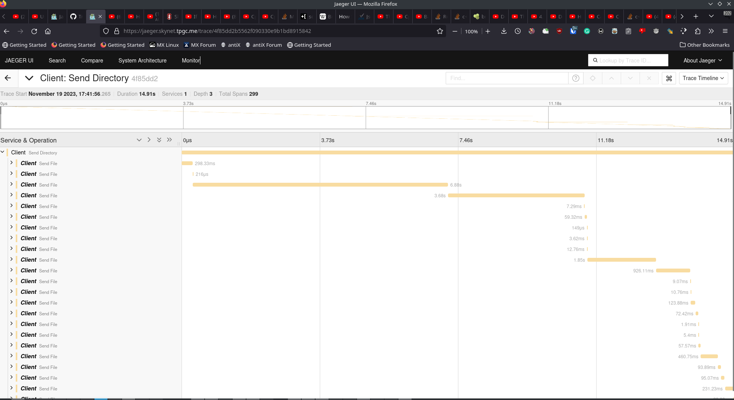

These might not work in the future because I don't have persistent storage setup on the docker container. But the endpoint will remain up for the forseeable future so feel free to run and test yourself (there is no passwording on it).

Evaluate how each selected feature or the combination of them impacts the
system's performance in terms of latency (time), throughput (speed), error rates or
other factors.

Yeah that's not going to happen. Next time skip the auto stuff and let me us C++ at least then I could automate most of that with black magic. Anyways LZ4 is faster than the network can send (it's insanely quick, nearly RAM speed compression / decompression). The hashing is similarly quick and the chunking is a basic requirement of sending data over a network since if you try to write to the output stream a data block larger than a packet there will be errors. Might be a way around that but after debugging the large packet issue for over an hour I don't think there is a way without making your own buffered writer. Maybe there is but it has been too long since I've used Java in a serious manor.

Deliverables:
• Source code for both the client and server applications.
- Included here
Provide comments in the code.
- you get what you get. I've spent enough time on this. My code is cleanish
• Open-Telemetry and visualization tool configuration/data files.
For security reason I am not providing my private servers' config files. This should've been stuff that WAS PROVIDED AS RESOURCES FOR THE ASSIGNMENT. (see footnote about most people never doing this kind of work)

• Screenshots or screen recordings of the visualization dashboard.
- Included a bit
• A report explaining implementation details, performance analysis, findings and any challenges faced.
- Consider this document's passive agressive nonsense to be for this (see endnote)

Part 2b:
We added a random delay of 0 to 10ms to the client's send file. It is clear on Jaeger:
The new trace timeline:
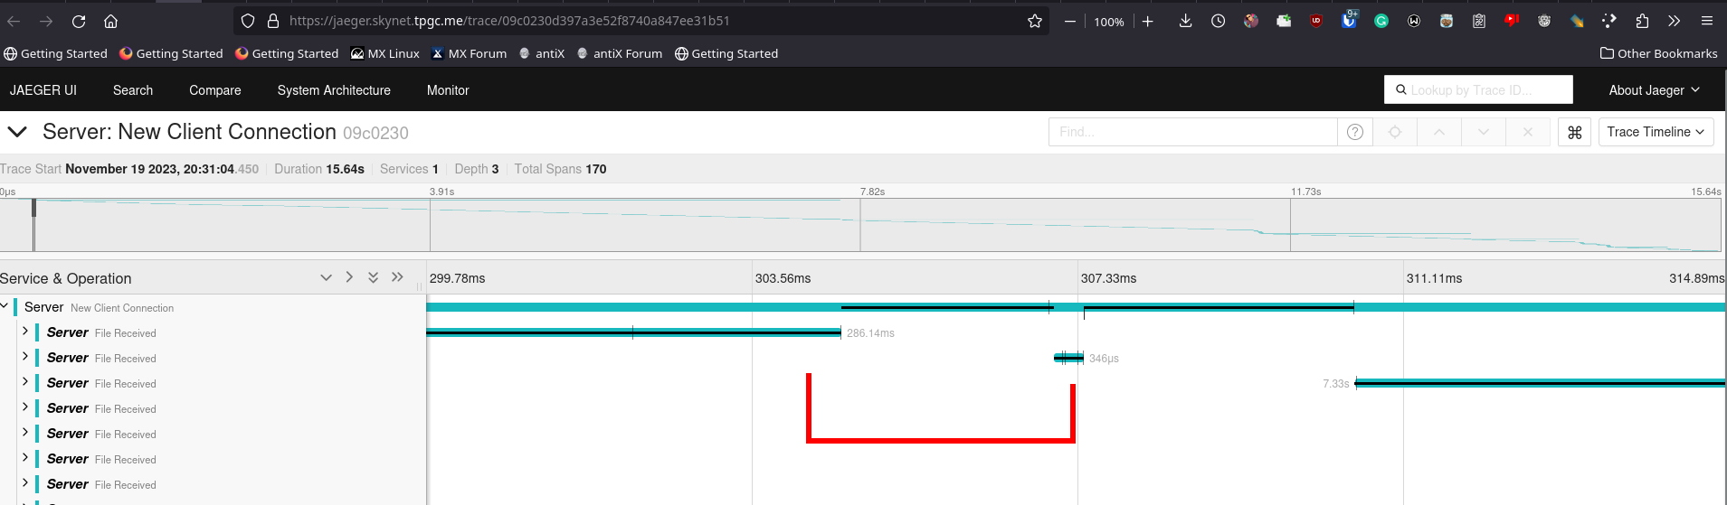
Vs the old for the same spot:
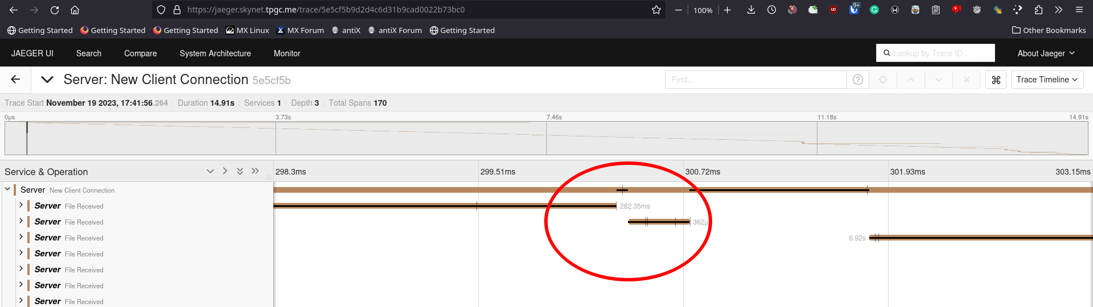
We can see there is a clear bug in the code. The client takes way too long to send another.

We can see this even clearer without room for potential for "but oh it's a fluke" when we look at small files being send sequentially. The old data shows very quick sending of files.
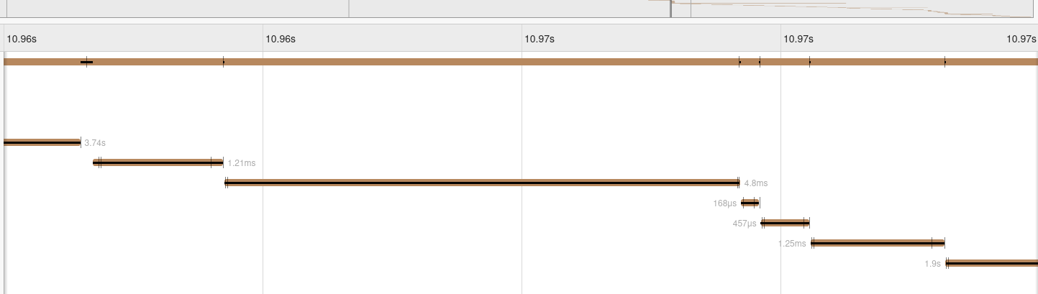
Vs the code with bugs in it:
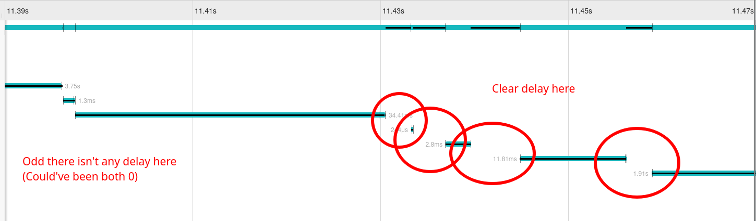
I'm not sure how much you guys want, the lack of mark distrabution is annoying + the overall length of this assignment is generally unappealing to continue. Suggestion: Have us actually make our own basic SD suite that doesn't send data to servers and insteads maybe outputs to a file? Something like a CSV since that is easy to use. We'd actually learn what SD was instead of "learning" a bunch of frameworks that we'll never use. Overall 0/10 assignment. Very boring, tedious and annoying.

It's pretty clear if I remove the delay lines that it will go back to normal, thereby showing I removed the bug (bonus time?)
See:
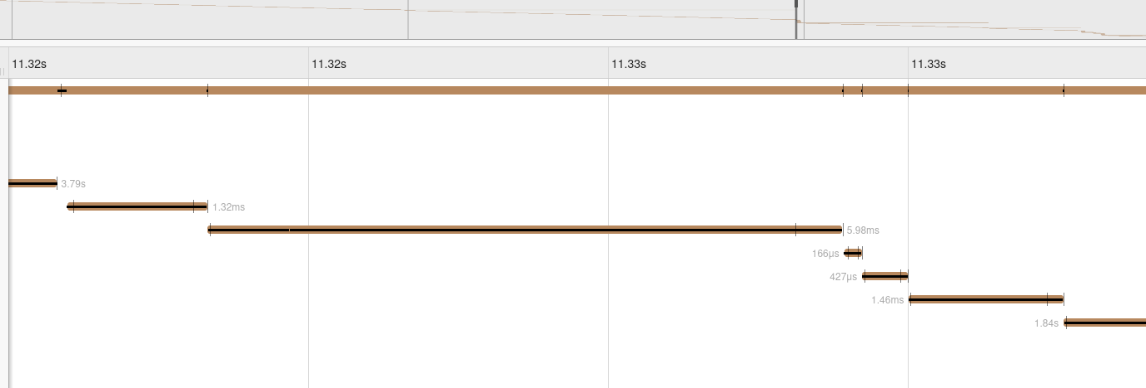

For what it's worth Mr.TA I don't mean the passive agressiveness to be directed towards you. You guys are marking it and have to deal with the prof's insane requirements too, all of which seem to stem from laziness + a fear of ChatGPT. Well fear isn't the right word. More like brain rot. So if you want to join us in a revolution to get a better CS department.... (for legal reasons this is a poor taste joke)

I should not have to and will not use ChatGPT just to complete an assignment. I'm not here to use AI tools to build software for me. Im here because I actually like computers/computer science, it is my 'special' interest. (fun way of saying hyperfixation)

If the use of ChatGPT was not intended as I think it was, well. Oof. Naser should get checked for an aneurysm

Like looking at the slides for SD it sounds really interesting to implement myself. In fact when I have time I will actually be adding a micro logging / tracing framework to my C++ general purpose utility library. That would've been a 1000x better assignment to do that would actually teach the fundamentals of statistical debugging.

Of course that would better align to the interests of people like me, people who spend all day doing compsci because our brains say mmmm yes. Btw this is the current nicest most filtered version of this Doc v`1.5`

The lack of prereqs for networking means anyone who hasn't done it before would find even making a basic client/server setup hard. See other endnotes.

